Working with image files and resizing

Install Pillow

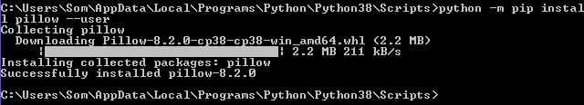
>>> from PIL import Image
>>> import os
>>> os.getcwd()
'c:\\py01'
# you can place the image file in the working directory ..
>>> img=Image.open(r"SPC00.png")
>>> img.show()

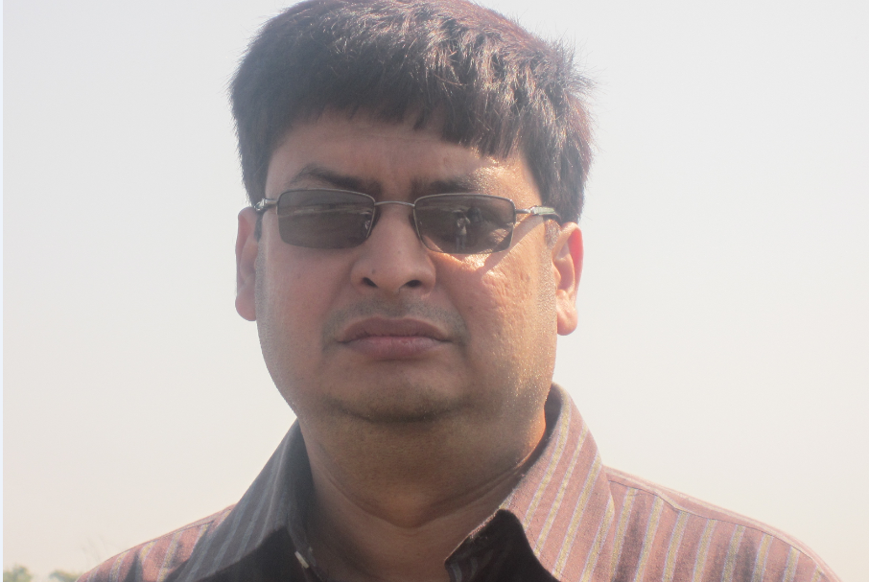

Want to rotate the image ?

>>> a=img.rotate(90)
>>> a.show()

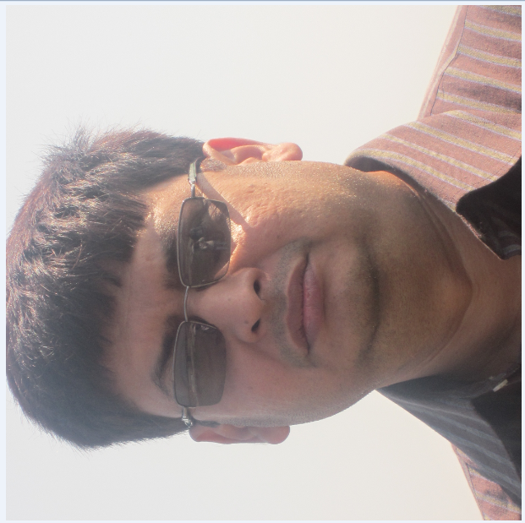

What is the size of the image in pixels ?

>>> img.size
(914, 610)

If you directly check the image property by right clicking it's the same

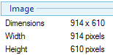

Want to check the image format ?

>>> img.mode
'RGBA'

So we can see that the image is a 32 bit image with 4 channels Red, Green, Blue and Alpha
transparency masking each 8 bits

How to resize an image and display ?

size=(182, 122)

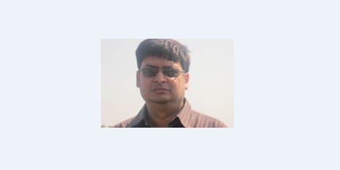

>>> from PIL import Image
>>> img=Image.open(r'SPC00.png')
>>> size = (182, 122)
>>> newimg=img.resize(size)
>>> newimg.show()

How about saving a resized image ?

>>> newimg.save(r'resized00.png')
>>> newimg=img.resize(size, resample=Image.BILINEAR)
>>> newimg.save(r'resized00.png')
>>> nimg=Image.open(r'resized00.png')
>>> nimg.size
(182, 122)
>>> nimg.show()

let's try to open a Grey Scale 8 bits and 1 bit BMP image after necessary modifications in Photoshop

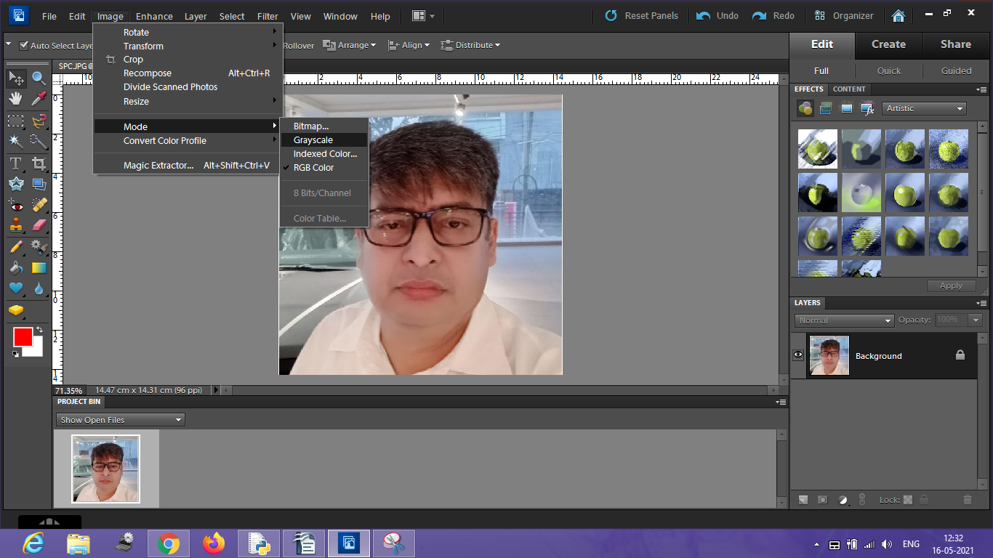

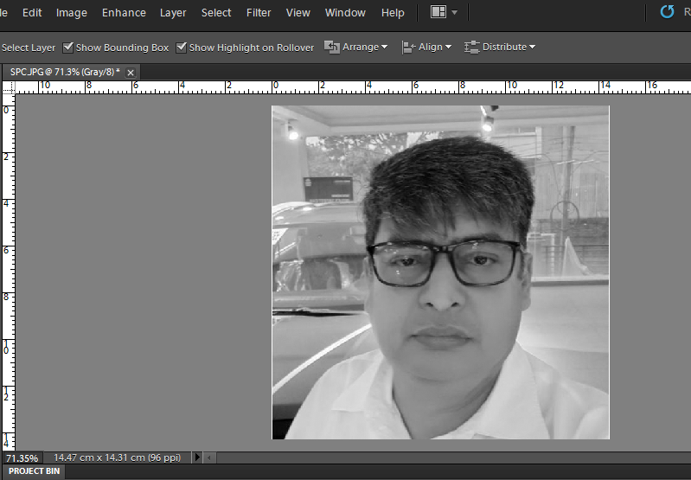

And an one bit BMP

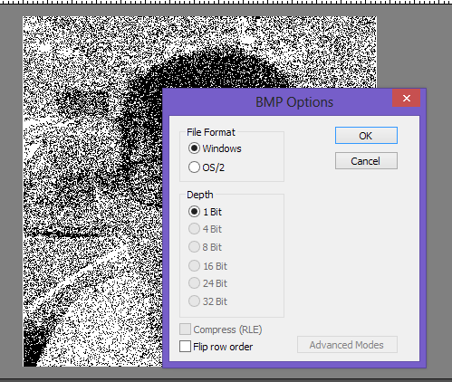

The files are named as SPC_GREY.JPG (8 bits) and SPC_GREY_01.BMP ( 1 bit)

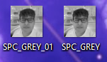

>>> img=Image.open(r'SPC_GREY.jpg')
>>> img.mode
'L'
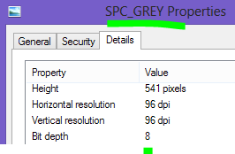

L indicates an 8 bit pixels, GreyScale image

>>> img=Image.open(r'SPC_GREY_01.bmp')
>>> img.show()
>>> img.mode
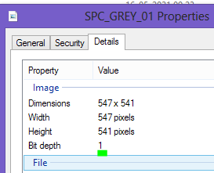
'P'

